AUSTIN HIGH GIRLS BASKETBALL

2016-2017 Sponsorship Form
We thank you for your commitment to helping our Lady Maroons Basketball team in our fundraising efforts. Funds from sponsorships are used to help purchase uniforms, equipment and scholarships for the program. Your donation also helps benefit other AHS Athletic programs.
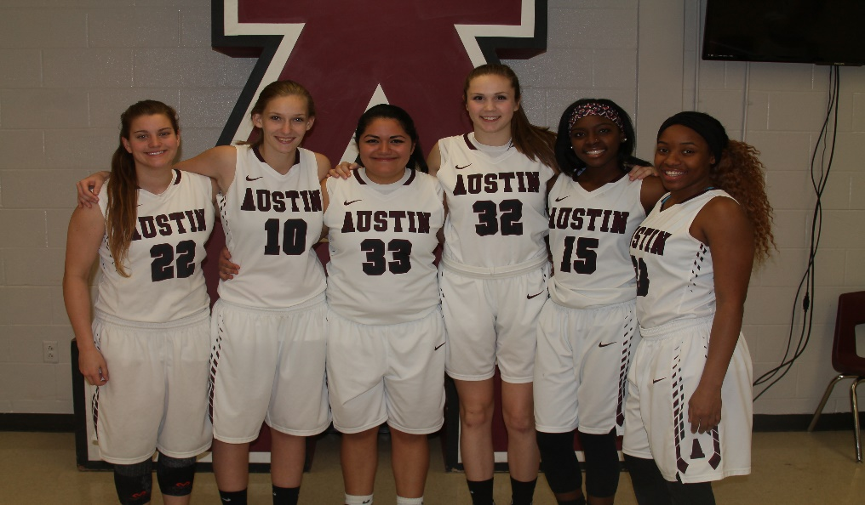
2015-2016 Senior Scholarship Recipients

Name of sponsor: ________________________________

Contact phone/email: _____________________________

Player who sold sponsorship: ________________________

Sponsorship

Levels

Level 1
Slam Dunk Sponsor $250-$500
Your name or logo on team t-shirt, poster, weekly game program AND gym banner

Level 2

Three Point Sponsor
$100-$249
Your name or logo on team t-shirt, poster,
weekly game program

Level 3
Fan Club Sponsor $50 Your name on team t-shirt and poster

Deadline: Friday November 4th, 2016

Please provide digital logo

Make checks payable to:
AHS Girls Basketball Boosters
Mail to:

AHS c/o Tricia Hughes
1715 W. Cesar Chavez
Austin, TX 78703

Please contact Kim Heide with any
questions: Kimheide97@gmail.com
512-350-5982

